Project Report

DATA MINING AMES SALMONELLA TEST RESULTS FOR CARCINOGENICITY AND MUTAGENICITY

TEAM MEMBERS:

Sucharu Gupta;

Nagadhatri Chennavajula;

Andrew Wong;

Sprush Ujjwal

|  |
| --- |
|  |

**Abstract**

Determining the toxicity of chemicals is necessary to identify their harmful effects on humans, animals, plants, or the environment. It is also one of the main steps in drug design. Animal models have been used for a long time for toxicity testing. However, in vivo animal tests are constrained by time, ethical considerations, and financial burden. Therefore, computational methods for estimating the toxicity of chemicals are considered useful. In silico toxicology is one type of toxicity assessment that uses computational methods to analyze, simulate, visualize, or predict the toxicity of chemicals. This report discusses the use of data mining techniques to study estimators of toxic potency in toxicological databases. Data Mining was used to uncover the patterns and present the knowledge discovery in the databases (KDD).

**INTRODUCTION**

In our everyday life we have to deal with an ever increasing number of new and different chemical compounds, such as food colourings and preservatives, drugs, dyes for clothes and ordinary objects, pesticides and many others: at present the number of registered chemicals is estimated at 28 million. It is well recognised that uncontrolled proliferation of new chemicals may pose risks to the environment and people; hence, their potential toxicity has to be considered. Biologically active chemicals interact with biomolecules, triggering specific mechanisms, such as the activation of an enzyme cascade or the opening of an ion channel, which lead to a biological response. These mechanisms, determined by the chemical properties, are unfortunately largely unknown; thus, toxicity tests are needed. Mutagenic toxicity, also called mutagenicity, can be assessed by various test systems. It is a property of high public concern because it has a close relationship with carcinogenicity and, in the case of germ cell mutations, with reproductive toxicity. For assessing the potential of a chemical to be toxic, a significant breakthrough was the creation of cheap and short-term alternatives to the rodent bioassay, the main tool of the research on chemical carcinogens. With this intent, Bruce Ames created a series of genetically engineered Salmonella Typhimurium bacterial strains, each strain being sensitive to a specific class of chemical carcinogens. As discussed in other papers, the estimated inter-laboratory reproducibility of this in vitro test is about 85%. This observation will be taken into account in the conclusive discussion. Alongside classical experiments for assessing toxicity, the use of computational tools is gaining more and more interest in the scientific community and in the industrial world as accompaniment to or replacement of existing techniques.

Whereas animal tests are very expensive and time consuming, high throughput computational approaches, otherwise known as in silico models, are broadening the horizons of experimental sciences: with increasing sophistication of such models, we are increasingly moving from experiments to simulations. A critical quantitative component of such studies is statistical characterization of the dose-response to the agent, and whether this response is indicative of a significant toxic effect in the system under study. Summary measures describing the potency of the agents toxicological activity are of interest, and the development of such measures is an area of active statistical research. In recent years, rapid technological and scientific developments

have enhanced our ability to generate large amounts of toxicological data on a variety of endpoints, even when a laboratory’s resources are limited. As a result, a wealth of archived toxicity database has emerged; Databases with such huge information represent excellent sources for studying the statistical characteristics of newly-developed (and some older) estimators of toxic potency. In effect, this represents a form of data mining, where information buried in large collections of data is quarried in a systematic fashion to uncover data characteristics. Data mining is often used in identifying/manipulating quantitative structure-activity relationships (QSARs) of hazardous chemicals, and there are strong overlaps between the use of data mining for potency estimation and that for QSAR identification. One can also use toxicological

databases to study quantitative activity-activity relationships (QAARs), where, say, the mutagenic activity of a set of hazardous chemicals is compared for predictive purposes

against their carcinogenic activity. Data mining is also growing in allied applications such as pharmacology and drug discovery, ecotoxicology, and in the burgeoning studies of gene expression, microarrays and toxicogenomics.

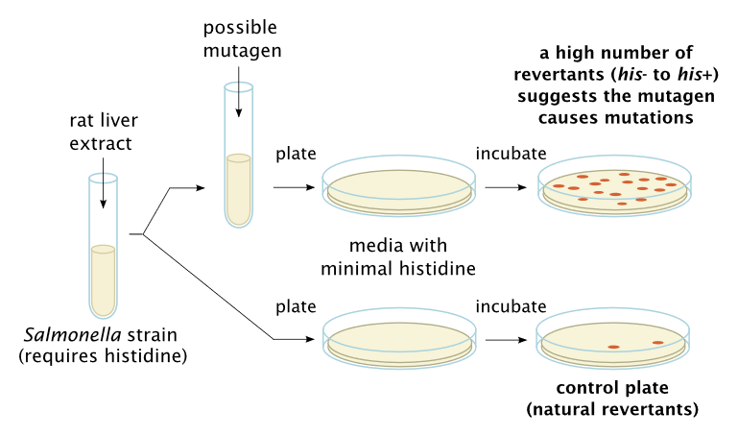

**DESCRIPTION:**

Determining the toxicity of chemicals based on Dose , count and other affecting factor. This is necessary to identify their harmful effects on humans, animals, plants, or the environment.

**Project Purpose:**

The purpose of this project is to give the users with a forum where they can check the toxicity of the chemicals which would help them to identify the factors they need to take care before distributing the chemical to the user base. This would help to prevent possibility restricting cancer mutagen chemical to the environment.

**REQUIREMENTS:**

**Functional Requirements**

**Primary:**

1. Provide a table to user to see from the test data if there are chemicals with matching inputs.
2. Users can check on the blog, toxicity of the chemical based on the given inputs.
3. Output should be mutagen or non-mutagen

**Secondary:**

1. User can compare the outputs from different best ML algorithms.

**Technical Requirements:**

1. Statistical Analysis and reporting
2. If possible system should be hosted on open source, cloud platform to allow users to access the application.

**UI DESIGN PRINCIPLES:**

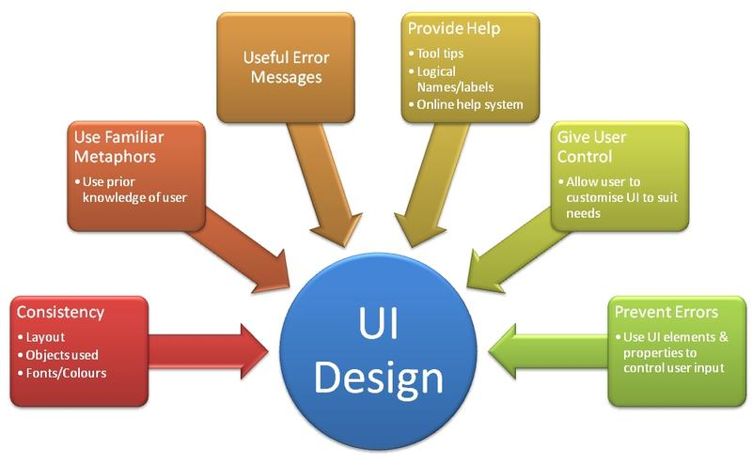

**Storyboard:**

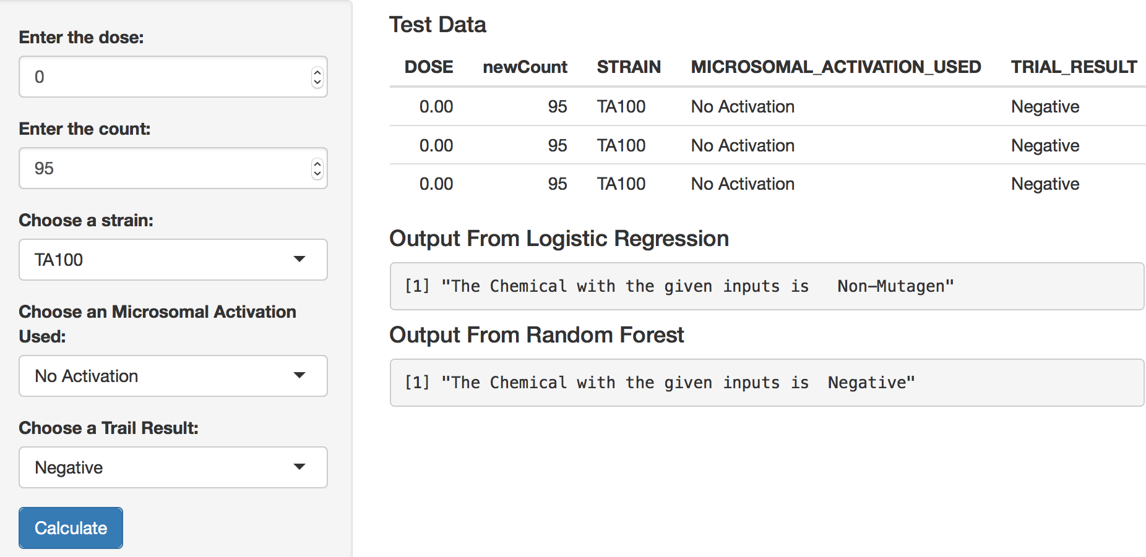

**High Level Architecture Design**

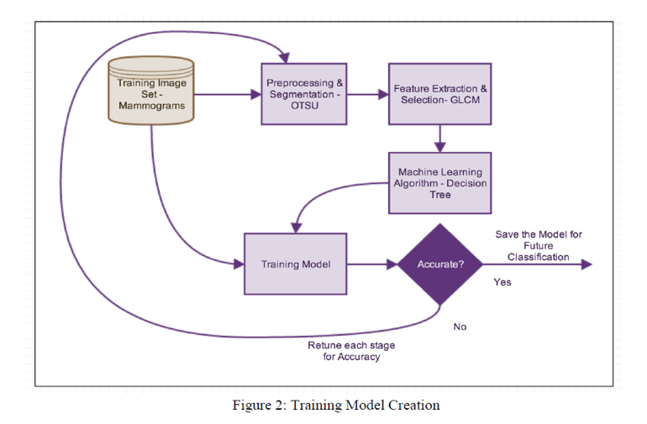

**Datasets & Data patterns**

GENETOX_Bacterial mutagenicity_NTP data is in chemical-in-rows format, comma-separated values. GENETOX_Bacterial mutagenicity_NTP.txt is 640.9MB .

final_project_data folder in Project [directory](http://www.kdnuggets.com/data_mining_course/data/index.html) has 3 files:

* GENETOX_Bacterial mutagenicity_NTP.txt
* gene.train.csv (training data, 1.5MB)
* Gene.valid.csv (validation data, 354 KB)
* Test.data.csv (test data, 459 KB)

**Data patterns**

From the dataset the data is not normally distributed. When we look at the plots for Dose and Count which are our main predictors for the analysis , data looks more gamma distributed.

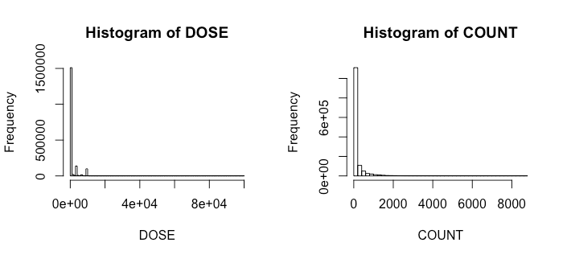

**Plot of the class (STUDY_CONCLUSION)**

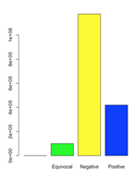

**Plot of MICROSOMAL ACTIVATION USE**

|  |  |  |
| --- | --- | --- |
|  |  |  |

**Data Flow Diagram & Architecture**

|  |
| --- |
|  |

Data mining holds great potential for the healthcare industry to enable health systems to systematically use data and analytics to identify inefficiencies and best practices that improve care and reduce costs. Here we took NTP dataset and did cleaning and preprocessing.We divided the dataset into training,test and Validation dataset.Further extraction of features and selecting them for running various algorithms to see which one will work appropriately to this dataset. We tried all our models on training dataset, finalised our model and then we run our model on test dataset to see whether it’s predicting correctly and run on validation dataset to see whether our model will work for future data or not?

**DATA MINING PRINCIPLES**

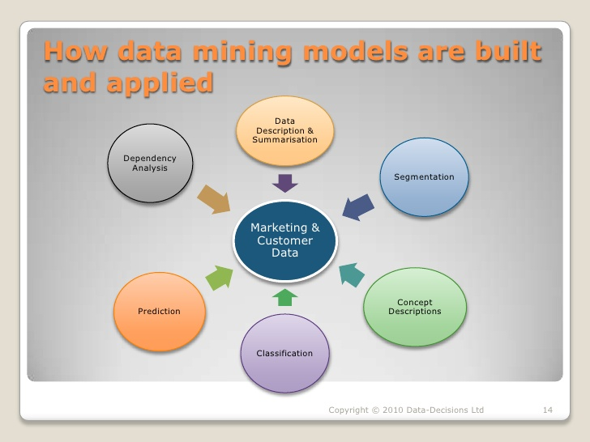

Use the following in the Rstudio :-

* Logistic Regression
* Multinomial Regression
* Random Forest
* SVM

**Logistic Regression:**

This is a [regression](https://en.wikipedia.org/wiki/Regression_analysis) model where the [dependent variable (DV)](https://en.wikipedia.org/wiki/Dependent_and_independent_variables) is [categorical](https://en.wikipedia.org/wiki/Categorical_variable) that is, it can take only two values, like whether the genes are mutagen or not. These are represented by “1” or “0”.Then regression analysis can be done by this. In our project we need to decide if the chemical is mutagenic or not. We came up with two best models and ROC curve for the model is below.

**ROC Curve**

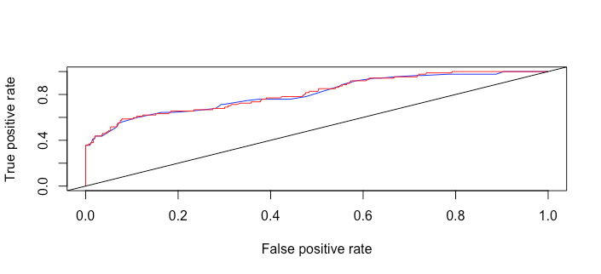

**MULTINOMIAL REGRESSION**

As logistic regression can be done on binary evaluation and in our dataset we need to test for outcome which had 3 classes , so we are using Multinomial logistic regression, which is a [classification](https://en.wikipedia.org/wiki/Statistical_classification) method that generalizes [logistic regression](https://en.wikipedia.org/wiki/Logistic_regression) to [multiclass problems](https://en.wikipedia.org/wiki/Multiclass_classification), i.e. with more than two possible discrete outcomes.That is, it is a model that is used to predict the probabilities of the different possible outcomes of a [categorically distributed](https://en.wikipedia.org/wiki/Categorical_distribution) [dependent variable](https://en.wikipedia.org/wiki/Dependent_variable), given a set of [independent variables](https://en.wikipedia.org/wiki/Independent_variable). In this we have variable values like Positive,Negative,Equivocal.

|  |  |  |  |
| --- | --- | --- | --- |
| **model.predict** | **Equivocal** | **Negative** | **Positive** |
| **Equivocal** | **28** | **0** | **9** |
| **Negative** | **93** | **631** | **29** |
| **Positive** | **0** | **0** | **19** |

**Confusion Matrix**

**RANDOM FOREST**

Decision trees are a popular method for various machine learning tasks. Branches of trees that are grown very deep tend to learn highly irregular patterns:-

they [overfit](https://en.wikipedia.org/wiki/Overfitting) their training sets, i.e. have [low bias, but very high variance](https://en.wikipedia.org/wiki/Bias%E2%80%93variance_tradeoff). Random forests are a way of averaging multiple deep decision trees, trained on different parts of the same training set, with the goal of reducing the variance. This comes at the expense of a small increase in the bias and some loss of interpretability, but generally greatly boosts the performance of the final model.

|  |  |  |  |  |
| --- | --- | --- | --- | --- |
|  | Equivocal | Negative | Positive | Class.error |
| Equivocal | 157 | 312 | 1 | 0.66 |
| Negative | 17 | 2571 | 1 | 0..06 |
| Positive | 3 | 166 | 101 | 0.62 |

**Support Vector Machine**

The support vector machine is a powerful classifier that has been successfully applied to a broad range of pattern recognition problems in various domains, e.g. corporate decision making, text and image recognition or medical diagnosis. Support vector machines belong to the group of semi parametric classifiers. The selection of appropriate parameters, formally known as model selection, is crucial to obtain accurate classification results for a given task. Striving to automate model selection for support vector machines we apply a meta strategy utilizing genetic algorithms to learn combined kernels in a data-driven manner and to determine all free kernel parameters. The model selection criterion is incorporated into a fitness function guiding the evolutionary process of classifier construction. We consider two types of criteria consisting of empirical estimators or theoretical bounds for the generalization error. We evaluate their effectiveness in an empirical study on four well known benchmark data sets to find that both are applicable fitness measures for constructing accurate classifiers and conducting model selection. However, model selection focuses on finding one best classifier while genetic algorithms are based on the idea of recombining and mutating a large number of good candidate classifiers to realize further improvements. It is shown that the empirical estimator is the superior fitness criterion in this sense, leading to a greater number of promising models on average.

**TRUE**

|  |  |  |  |
| --- | --- | --- | --- |
| Pred | Equivocal | Negative | Positive |
| Equivocal | 50 | 7 | 0 |
| Negative | 71 | 616 | 24 |
| Positive | 0 | 8 | 33 |

**Confusion Matrix**

**Comparing the models (CART, SVM, RF)**

|  |
| --- |
| Accuracy  Min. 1st Qu. Median Mean 3rd Qu. Max. NA's  CART 0.8078 0.8318 0.8363 0.8376 0.8476 0.8589 0  SVM 0.8288 0.8506 0.8559 0.8585 0.8649 0.8949 0  RF 0.8288 0.8506 0.8559 0.8585 0.8649 0.8949 0  Kappa  Min. 1st Qu. Median Mean 3rd Qu. Max. NA's  CART 0.2641 0.3789 0.3963 0.4064 0.4575 0.4973 0  SVM 0.3786 0.4764 0.5237 0.5122 0.5445 0.6572 0  RF 0.3786 0.4764 0.5237 0.5122 0.5445 0.6572 0 |

**BOX PLOTS**

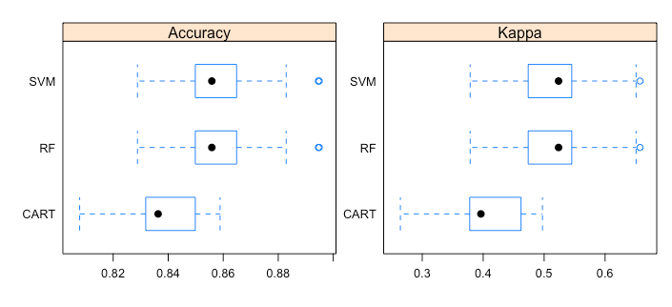

**Density Plots**

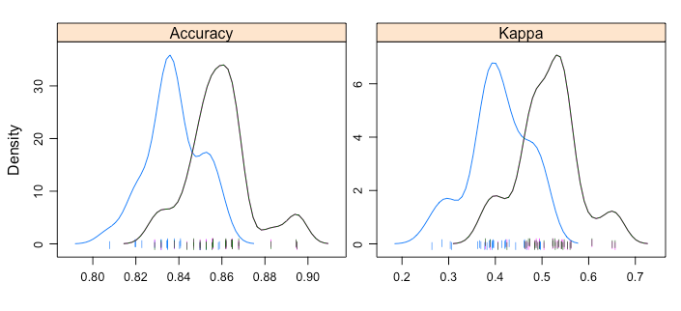

**Dot plots of accuracy**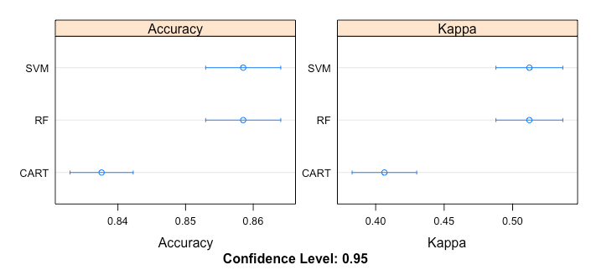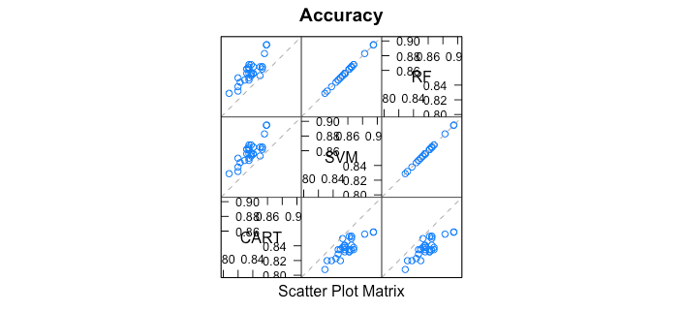

**Summary of differences in the models**

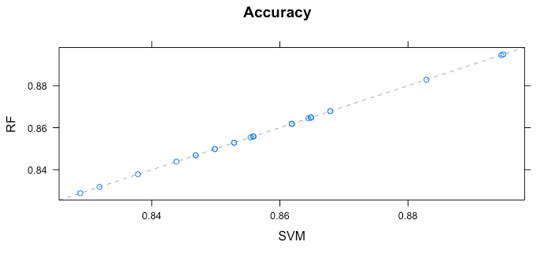

**KDD Principles**

Data mining is also sometimes called Knowledge Discovery in Databases (KDD), because the purpose of KDD is to extract of interesting information from data in large database, and analyze them to find patterns for big data through techniques in statistics, artificial intelligence and database management. Knowledge Discovery Process is an iterator process with the aim of finding and interpreting patterns from data that leads to the following steps, and they are Data Cleansing, Data Integration, Data Selection, Data Transformation, Data Mining, Pattern evaluation, Knowledge Presentation.

* Development of Understanding
  + To choose the domain with pre-existing knowledge in it and to create the goals of the project to end-user.
  + We choose the domain of Ames test which is a popular method that utilizes bacteria on a trial whether a given chemical that can cause mutations in the DNA of the organism. The goal of the project to uncover the patterns and to build an estimator of toxic potency from toxicological databases.
* Target Data Set Creation
  + To select a data set or subset of it.
  + We found the data source at National Institutes of Environmental Health Science, and they provide the dataset about Chemical Effects in Biological Systems.
* Data Cleansing
  + To remove noise and inconsistent data.
  + We have done data cleansing due to missing values to the selected dataset.
* Data Integration
  + To combine data where comes from multiple sources.
  + We only use the single data source, no need to merge or combine data.
* Data Selection
  + To retrieve relevant data for analysis from database.
* Data Transformation
  + To transform or consolidate into appropriate form for data mining.
* Data Mining
  + To extract data patterns through intelligent approaches.
* Pattern Evaluation
  + To identify interesting patterns inside scope representing knowledge discovery.
* Knowledge Presentation
  + To visualize and present knowledge of what knowledge has been mined.

**Data Tools**

* R
* R Studio
* Shinny
* AWS

**Client Side Design:**



**Testing:**

Testing of the model is done using 10 fold cross validation repeated 3 times.

As the problem is classification problems, we used stratified k-fold cross-validation, in which the folds are selected so that each fold contains roughly the same proportions of class labels.In repeated cross-validation, the cross-validation procedure is repeated n times, yielding n random partitions of the original sample. The n results are again averaged (or otherwise combined) to produce a single estimation.

**Design Patterns Used**

**Lambda architecture**

Except if you go for online learning (update the model after every example), need to retrain your model regularly and cross-validate its performance. On the other hand we need our model to be able to predict over real-time or simply incoming data. That means we need two layers. One where the data goes for predictions, one where it is historicized and used for regular trainings. There will be a lot of code in common, such as your processes for feature creation, data cleaning, configuration for the machine learning libraries and so on.The "fake" disclaimer is because we don't have a serving layer .